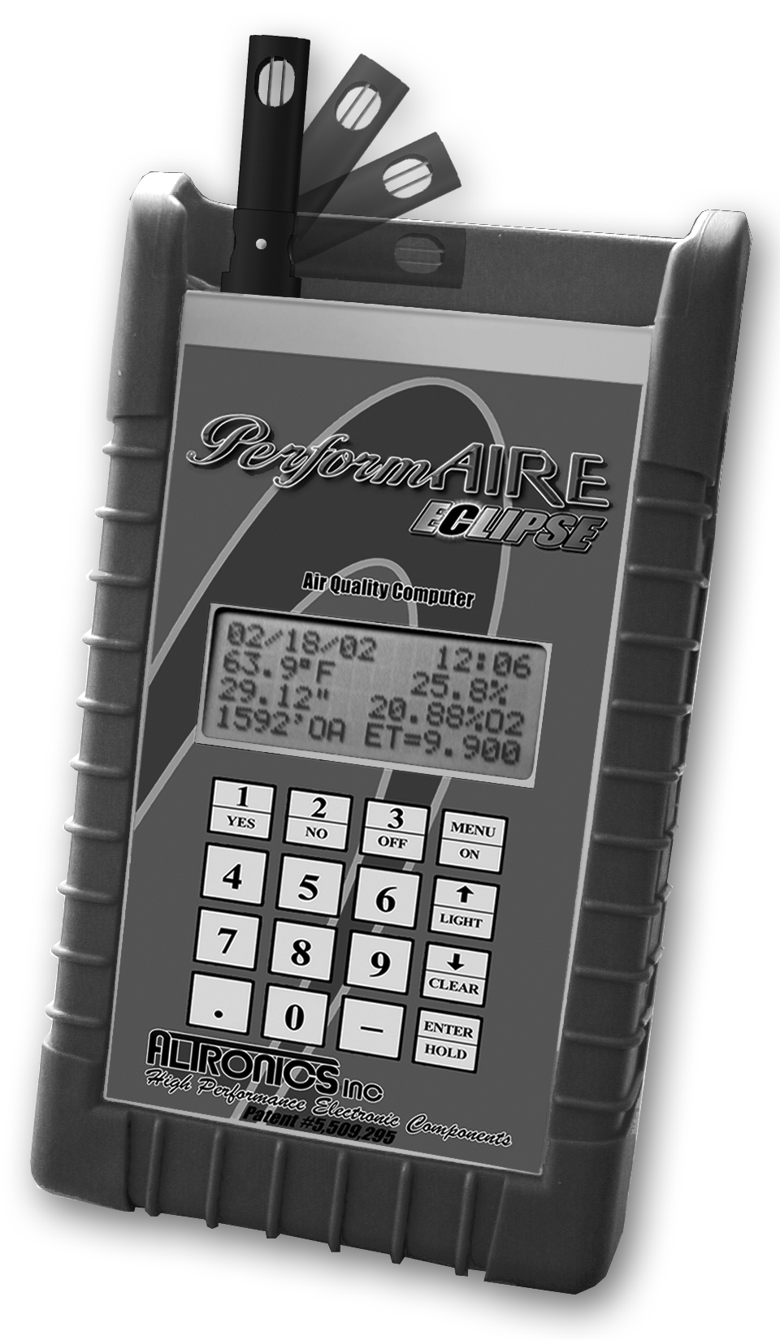
Air Quality Computer

U.S. PATENT #5,509,295


Invented and Manufactured By

1411 S. Roselle Rd Schaumburg, IL 60193
847-923-0002
847-923-0004 Fax
www.AltronicsInc.com

Table of Contents
FEATURES 2
GETTING STARTED 3
TAKING AIR SAMPLES 3
THE KEYPAD 5
THE MENU SYSTEM 5
SAMPLE AIR READINGS 6
SETUP 9
ET MODE ______________________________________ 10
THROTTLE STOP MODE________________________ 10
JET MODE _____________________________________ 13
EZ PLATE MODE___________________________ 14
WIND PREDICTION ____________________________ 15
RUN ENTRY __ 16
SEA LEVEL ET 16
THROTTLE STOP RATIO 16
WEATHER ON HOLD 16
VIEWING/DELETING RUNS 16
RUN COMPLETION 17
MAKING PREDICTIONS 18
DOWNLOADING TO A PC 20
SET CLOCK 22
BAD RUNS 22
AUTO POWER OFF 22
SAMPLE METHOD _______ 23
BATTERY CHECK 24
RECHARGING BATTERY _____ 24
UPDATING FIRMWARE _________________________24
OPERATING/STORAGE LIMITS 25
WARRANTY 25
TECHNICAL SUPPORT 25
RESET/REBOOT SYSYTEM ___ 26
ABBREVIATIONS 26
GUIDELINES FOR ACCURATE PREDICTIONS 27
APPENDIX 28
PerformAIRE ECLIPSE FEATURES

- Temperature Readout
- Relative Humidity Readout
- Absolute Barometric Pressure Readout
- Dew Point
- Vapor Pressure
- Grains of Water
- Air Density Ratio
- Wind Speed and Gust (optional)
- Oxygen Sensor Readout (optional)
- Density Altitude Readout
- Oxygen Altitude Readout (optional)
- 400 run data base
- Up to 10 separate data bases
- Sea level ET calculation
- Throttle stop ratio calculation
- ET to DA Ratio
- ET prediction
- Throttle stop prediction
- EZ PLATE prediction
- One run prediction
- Wind effect prediction
- Run completion
- Bad Run Detection
- Data and time stamp in data base
- Weather on Hold
- Manual weather input
- Automatic Last weather sample Hold
- View and delete runs
- Downloading Data Analysis software (optional)
- Battery low indication and power level
- Lithium Ion Rechargeable Battery
- Backlit LCD display
- Automatic power off
- Protective rubber boot and wrist strap
GETTING STARTED
Press “MENU” key to turn unit on. Unit will automatically turn off after 2 minutes if no keys have been pressed.

GREETING MESSAGE
The PerformAIRE
By ALTRONICS
O2 EQUIPPED
VERSION 1.* (Firmware Version)

"O2 EQUIPPED" will only appear if the unit was purchased with an oxygen sensor.
DATA BASE #1
ET MODE Selected
Multiple Run Prediction

Wind Prediction Enabled

Second greeting message above will show the following info about the “Setup” of the unit: Data base, prediction mode, prediction type, and wind effect.

TAKING AIR SAMPLES
- Place PerformAIRE in an area that will constantly expose it to the air you will be racing in (out side of trailer).
- Do not place your hand or any other object near the air vent while PerformAIRE is in use.
- Do not place PerformAIRE near soil or grass as it may pick up additional humidity.
- Although the PerformAIRE is reasonably durable, it can be damaged if dropped or abused. Keep this in consideration when using and storing the PerformAIRE.
- Although PerformAIRE work accurately in direct sunlight keeping it shaded will allow it to stabilize faster.

**IMPORTANT**
Units with oxygen sensors only:
When using a unit with an oxygen sensor that is set to Oxygen Altitude mode, the unit must remain stabile while in use. If movement has agitated the unit it must remain stable for 15 minutes before taking air samples. Unit does not need to have power on to stabilize!!!!

******Important******
It often takes a number of trips to the track to acquire the recommended data in order to produce accurate results. Because of this, we suggest using the following method until enough data has been acquired or using the One Run Prediction Method (See Page 11).

Gasoline burning engines:
A 200’ rise in DA typically yields a 0.01sec slow down in ET and vice-versa for a drop in DA.

Alcohol burning engines:
A 400’ rise in DA typically yields a 0.01sec slow down in ET and vice-versa for a drop in DA.

For TS racers:
Typically the TS ratio is 3:1. This means is takes 0.03sec in the timer to move the car 0.01sec. Use this information with the above DA change to set up your timer.

If you read nothing else, please read GUILDLINES FOR ACCURATE PREDICTIONS on page 27!!!!!!!!!

KEYPAD FUNCTIONS
MENU/ON key - Turns unit ON and allows the unit to leave any current menu and return to the MAIN menu.

▲/LIGHT key - used to scroll up and turn backlit on. The backlit can only be turned on and off when unit is in the main menu or when weather data is being displayed.

▼/CLEAR key – Scrolls down and is used to clear data.

3/OFF key – Turns unit off when pressed from MAIN menu. (NOTE: OFF key must be held for at least 1 full second). Unit turns itself off automatically if no keys are pressed for 1 minute.

ENTER/HOLD key - must be pressed after keying in a value to confirm the value is correct. When pressed in SAMPLE AIR mode the air sample is held in memory and can be used for data entry later on. To view the “Held” data you can press the HOLD key when you are at the main menu.
MENUS
MAIN MENU - When unit is turned on the MAIN menu automatically is displayed after the greeting message.

SAMPLE AIR/WIND = 1 (Wind optional)
SET UP = 2
RUN ENTRY = 3
PREDICT = 4
Hit the “MENU” key again and see:
DOWNLOAD =5
SET CLOCK =6
BAD RUNS =7
AUTO POWER OFF =8
Hit the “MENU” key again and see:
SAMPLE METHOD =9
BATTERY CHECK =0
Refer to Appendix for MENU chart
SAMPLE AIR/WIND

SAMPLE Wind (Optional)
After selecting option 1 a second menu prompt will follow if unit is equipped with wind sensor:
SAMPLE Air =1
SAMPLE Wind =2

Selecting option 2 will display average wind reading along with max wind gust:
5.0MPH 10.2Gust

Exit->Press MENU

After wind reading has stabilized, press and hold the MENU button to exit wind readings and save wind values. The saved wind values can be used when storing runs or correcting wind effects when predicting. Saved wind values will automatically be displayed at appropriate prompts and user can confirm value or change if desired.

TAKING WIND READINGS
- Lift end of wind sensor up and sensor arm will snap into position. When wind reading is complete, push end of sensor back to closed position.
- Face back of unit towards wind and note direction in reference to vehicle (Head, Tail , Cross).
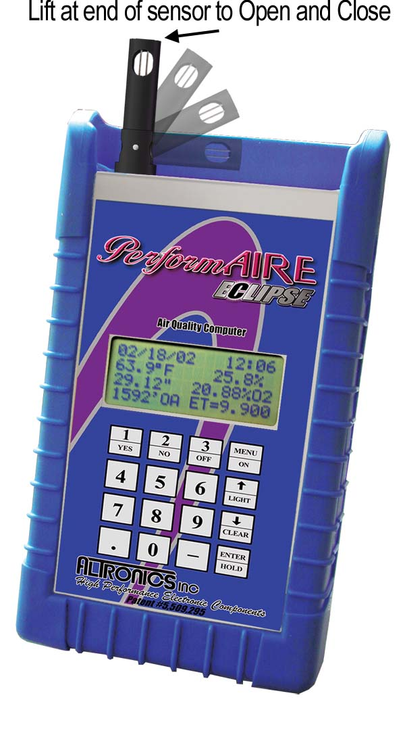
SAMPLE Air
By pressing "1" from the menu the unit displays all the sampled air parameters and the PREDICTION in the following format:

DATE TIME
TEMP HUMIDITY
PRESSURE OXYGEN (if equipped) / DEW POINT or GOW VAPOR PRESSURE
ALTITUDE/CF PREDICTION (ET, TS, JET or PLATE)

The third and fourth line on the display will alternate from showing Pressure and Oxygen to Dew Point and Vapor Pressure and Altitude to Horse Power Correction Factor (CF). Dew Point can be replaced to show Grains of Water (GOW). See SETUP.

Upon exiting the SAMPLE Air screen the unit will automatically save the last sampled data as CURRENT data,. You can also Press the “ENTER” key while viewing data. This will HOLD the data to be used later for entering runs. To view the “Held” data you can press the HOLD key when you are at the main menu. Therefore you can use either the CURRENT or the HELD data when entering or predicting data.

If the unit has been set to Auto Stable from the SAMPLE METHOD menu the following will be displayed when SAMPLE AIR is selected:

Stabilizing XX%
Stabilizing will show the percent the unit has stabilized and will keep increasing percentage until it is 100%, then the weather sample will be displayed. Pressing and holding the MENU button while “Stabilizing” will cause unit to jump out and show air data.

If Wind Correction has been enabled in the SET UP menu the user will first be prompted to enter wind speed and direction before weather sampling begins.

The PREDICTION will be shown in the lower right hand corner only after two runs in ET or PLATE mode and three runs in TS mode have been stored in the selected data base. If less runs have been stored "***" will appear in the place of the PREDICTION value.

PLATE MODE: The predicted plate will appear in the lower right hand corner of the screen (example: “EZ= DL12” or “EZ= F08”). If the prediction is displayed as “EZ= ***”, you do not have enough runs entered to make a prediction. If the prediction is displayed as “EZ= N/A”, the prediction is for a plate larger than the largest possible plate, or smaller than the smallest possible plate.

NOTE: Barometric Pressure
The Pressure reading is “Absolute”, which means it will NOT agree with the weather channel or local forecast. This is due to the fact that the local forecast is gives a corrected pressure reading that is compensated back down to sea level. If you were to stand at your local airport and dig a hole down to sea level the PerformAIRE pressure reading would then agree with the local airport reading!

SET UP
By pressing "2" from the MAIN menu the unit enters SET UP. Set up allows for configuring any one of the 10 data bases or selecting weather variables to be displayed. Each data Base hold 40 runs.
The first menu appears...

Setup Data Base =1
Setup Weather =2
Setup Weather:
Pressing “2” displays the following menu and prompts the user to select “1” or “2” to display Grains of Water(GOW) or Dew Point(Dp F) when sampling the air.

Shows Grains =1
Show Dew Point =2

Setup Data Base:
Pressing “1” displays the following screen and prompts the user to select one of the 10 available data bases.

Select Data Base
Yes = 1 No = 2

After selecting a data base you will be asked if you want to clear all the runs out of it:
CLEAR RUNS?

Yes = CLEAR No = ANY KEY

You will now be asked if you want to rename it. Note: You can use the default name if you wish “Data Base #1”.

To enter a new name use the “SCROLL” key to scroll the letter up or the CLEAR key to scroll down. When the letter is correct select Yes by pressing “1” and you will go on to the next letter. When all the letters have been selected press the “ENTER” key to save the name.

Continue?
Yes = 1 No = 2
After selecting a data base you can exit out of SETUP if you have already previously configured it and do not wish to make any changes.

After selecting a data base the following is displayed:

ET MODE = 1
TS MODE = 2
JET MODE = 3
PLATE MODE =4
Select Mode

ET MODE: By pressing "1" sets the unit to the ET MODE. This means all runs added to the data base will be stored in the ET section and the PREDICTION will be an ET computed from the stored runs and the present ALTITUDE.
TS MODE: By pressing "2" sets the unit to the TS MODE (Throttle Stop Mode). This means all runs added to the data base will be stored in the TS section and the PREDICTION will be a TS or timer setting computed from the stored runs and the present ALTITUDE.
After pressing "2" another menu is displayed as follows:
TS MODE SELECTED
index = 9.90
CHANGE?
YES = 1 NO = 2

If the user presses "1" the following will be displayed:

ENTER INDEX
Now the user can enter an index, such as 8.90, then he must press the ENTER key.

Select Method
For Prediction
Multiple Runs =1
One Run =2
Multiple Runs:
When the multiple run prediction method is selected, predictions are then calculated from the runs stored in the data base.

Predict with
DA=1 OA=2
CF=3 VP=4
Now you must choose which weather variable to reference your prediction against. The standard is to use DA or OA (if the unit is oxygen sensor equipped), but you can select CF or VP if you wish.

One Run:
When One Run prediction method is selected you must set your base run and performance ratios.
Set Base Run=1
Set Pred Value=2
View Values=3
Done =ENTER
Set Base Run:
Your base run data should be taken from a “good run” or your last “good run”. You can update this data as you wish.
Enter Base Run
DA=
ET=
Timer= (if in TS mode)
Temperature= (if fuel type=Alcohol)
Humidity= (if fuel type=Alcohol)
Set Pred Values:
Set Prediction Values allows you to select your gas type and your DA to ET and TS to ET ratios.
Select
Gas=1 Alcohol=2

Now you will be prompted to choose between preset ratios or allowed to enter custom ratios.
Preset Ratios=1
Custom Ratios=2
Preset Ratios: Use Preset or “Typical” ratios if you do not know what your cars actual ratios are.
Custom Ratios:
Enter DA Ratio
Enter how many foot of Altitude it takes to move you vehicle 0.01sec in ET. (Ex: 150 means it takes 150’DA to make ET change 0.01sec)
Enter TS Ratio
Enter ratio that it takes to move ET of vehicle 0.01 sec. (EX: 2 means it is a 2:1 ratio or takes two 0.02 to move car 0.01 in ET)

View Values:
Allows you to view your base values and ratios to confirm your setup.

Predict with
DA=1 OA=2
CF=3 VP=4
Now you must choose which weather variable to reference your prediction against. DA is suggested.

Wind Prediction:
If you have chosen Multiple Run Prediction you will be prompted to select to use wind correction into you ET or TS predictions:
Predict w/Wind?
PRESS 1=Y 2=N
If you enable wind correction you will be prompted to select a vehicle type:
Select Car Type
Dragster=1
Door =2
Roadster=3

Next you can adjust the wind effect.
Adjust Effect?
Press 1=Y 2=N

Wind factors have been programmed to correct prediction for wind based on speed and direction of wind. You can further adjust the amount of correction by selecting to Adjust Effect:
Enter Value
Default (5)
(1-10)=
Selecting <5 means you are lessening and >5 increasing the wind correction.
The information in this box is only relevant if your unit is OXYGEN SENSOR equipped.

After pressing the ENTER key (from above) the following will be displayed:
PREDICT WITH
DENSITY ALT = 1
OXYGEN ALT = 2

PRESS 1 or 2
If your unit has the optional oxygen sensor you can choose to predict your ET or TS value with density altitude or oxygen altitude.
The unit will compute and store the density altitude and oxygen altitude after every sample. This means that when you add a run to your data base, the unit will automatically store both altitudes.

This enables you switch between predicting with either altitude and seeing how your stored runs compared with each.

JET MODE: By pressing "3" sets the unit to the JET MODE.
The jet program is based on the atmospheric calculation of Air Density Ratio (ADR). When the unit is “SET UP” in Jet Mode the ADR will be displayed in alternating fashion with the Density Altitude (DA) in the bottom left corner of the display when sampling air.

After selecting Jet Mode you will be prompted to select the appropriate jet type for your application:

Holley = 1 (Holley Jet Numbers 50 to 120)
Mikuni = 2 (Mikuni Jet Numbers)
Keihin = 3 (Keihin Jet Numbers)
Custom = 4 (Custom drilled jets, enter diameter of jet orifice. Example 0.042)

Next you will be prompted to enter a base setup. First you must enter the BASE ADR and then the BASE Jet Size. These base settings will be used to generate adjusted jet sizes for a change in ADR. You can go back and change base setting at any time. Valid ADR ranges from .7 to 1.2 Sea Level is equivalent to a 1.0 ADR.

To calculate adjusted jet sizes you can use SAMPLE AIR (option 1) or PREDICT (option 4) from the main menu.

SAMPLE AIR – the adjusted jet size, based on the current ADR, will automatically be shown in the lower right corner of the display as JS=XXX.X

PREDICT – will display the type of jet followed, by the base settings, and then prompt for input of the new ADR. After the ADR is entered the adjusted Jet Size will be displayed.

Example:
Holley
Base ADR=X.XXX BASE JET=XXX.X
New ADR=X.XXX
JET SIZE=XXX.X

EZ PLATE MODE: By pressing "4" sets the unit to the PLATE MODE.

PLATE MODE
Index = 9.90
CHANGE?
YES = 1 NO = 2

If the user presses "1" the following will be displayed:

ENTER INDEX

Now the user can enter an index, such as 8.90, then he must press the ENTER key.
SELECT SERIES
4150 = 1
4500 = 2
Next you can select which Plate series you use by pressing 1 or 2.

Predict with
DA=1 OA=2
CF=3 VP=4
Now you must choose which weather variable to reference your prediction against. The standard is to use DA or OA (if the unit is oxygen sensor equipped), but you can select CF or VP if you wish.
Wind Prediction:
You will be prompted to select to use wind correction into your Plate predictions:
Predict w/Wind?
PRESS 1=Y 2=N
If you enable wind correction you will be prompted to select a vehicle type:
Select Car Type
Dragster=1
Door =2
Roadster=3

Next you can adjust the wind effect.
Adjust Effect?
Press 1=Y 2=N

Wind factors have been programmed to correct prediction for wind based on speed and direction of wind. You can further adjust the amount of correction by selecting to Adjust Effect:
Enter Value
Default (5)
(1-10)=
Selecting <5 means you are lessening and >5 increasing the wind correction.

RUN ENTRY
By pressing "3" from the MAIN menu the unit displays the following:
VIEW/DELETE RUNS = 1

ADD RUNS = 2
TSR = 3
or
RATIO/SLET = 3

“TSR” (throttle stop ratio) is only displayed if the unit in TS MODE and more then two runs has already been stored. Pressing "3" displays the throttle stop ratio.

“RATIO/SLET” is displayed only if the unit is in ET MODE and more then two runs have already been stored. Pressing 3 displays your SEA LEVEL ET and your ALT/ET ratio. Your ALT/ET ratio tells the amount of change in ET there is for every 100’ of altitude change.

By pressing "1" you can view or delete runs you have already stored. Use the SCROLL key to view runs. If you want to delete a run you have scrolled to press the CLEAR key. By pressing the ENTER key when viewing a stored run it will show the Temperature, Humidity, and Pressure values stored for that run.

ADD RUNS: By pressing "2" the following ADD RUNS menu will be displayed:

Store with->
CURRENT = 1
HELD = 2
MANUAL = 3
You can store a run by using the “CURRENT” weather conditions by selecting 1, by using the “HELD” data that you saved by earlier by selecting 2, or by entering “MANUAL” values by selecting 3.

After selecting 1 or 2 the following will be displayed:
Enter Run Info->
DA=1000 (Example)
1000’ ET=
ET=, TS=, or PLATE=

The DA or OA will already be loaded. You should enter a 1000’ ET, a final ET, and TS. The 1000’ ET is optional and is used for run completing. You do not have to enter every run with a 1000’ time in order to use run completing. ** For 1/8” runs you can enter a 330’ time instead of a 1000’ time**

If manual entry is desired you must select number 3. After selecting 3 the following is displayed.
ENTER AS
Altitude =1
Temp, Hum, Press =2
Press 1or 2
If 1 is selected you will have to key in the DA or OA value. If 2 is selected you will have to enter the temperature, humidity, pressure, and oxygen values. Then the DA or OA will be calculated.

ET = will only be entered if the unit is in ET MODE.
TS = will only be entered if the unit is in TS MODE.
PLATE = will only be entered if the unit is in PLATE MODE
Each plate is identified by a letter followed by a number. First, you will choose the letter. To change the letter, scroll up to advance forward in the alphabet, and scroll down to advance backward. Once you have selected the correct letter, press the “Enter” key. Next, you will select the plate’s number. Scroll up to increase the number, and scroll down to decrease the number. Again, once you have selected the correct number, press the “Enter” key to continue. The run is now entered and you will be returned to the main menu.

Wind Correction:
If wind correction has been enabled you will be asked to enter the wind speed and direction for each run entered.

Enter Wind Speed
MPH=

Enter Wind Dir
Head=1 Tail=2
CH=3 Ct=4 Cross=5

****HINT****
The easiest way to enter a run is by starting from the main menu and pressing the keys 3, 2, 1, and ENTER. Now all you have to do is type in your ET’s and the run is stored.

RUN COMPLETION
In order use the run completion program effectively at least one previous run must be entered into a data base with a 1000’ ET. To use run completion all you need to do is enter the 1000’ et of the run you want to complete and then when it asks you to enter your final ET= simply press the enter key without any value. You will then see a Run Completing! message appear followed by ET=10.203 (example) your completed ET. This run will then be saved automatically and the main menu will be brought back, unless you are in TS mode, in which case, you will then be prompted to enter your TS. Run Completing is an approximation and it is NOT suggested to base a prediction on this type of data. Actual all out runs typically prove for more accurate predictions.

1/8 Mile Tracks
Keep 1/8 mile and 1/4 mile runs in separate data bases. You may want to name the data base appropriately.
If you run 1/8 mile and want to be able to use run completion you must enter in a 330’ time when the unit prompts you to enter the 1000’ time.
In regards to entering your ET for a 1/8 mile track simply enter in the 1/8 mile time.

PREDICT
Depending on the mode the unit is in (ET MODE, TS MODE, JET MODE or PLATE MODE) by selecting “4” you can input any altitude (DA) and the corresponding ET, TS, JET, or PLATE prediction will be displayed. You need to have two ET, two PLATE, or three TS runs a the data base before you will see a prediction.

It is more common to use the “SAMPLE AIR” menu option to see your current predicitions.

For PLATE MODE the predicted plate will appear in the lower right hand corner of the screen (example: “EZ= DL12” or “EZ= F08”). If the prediction is displayed as “EZ= ***”, you do not have enough runs entered to make a prediction. If the prediction is displayed as “EZ= N/A”, the prediction is for a plate larger than the largest possible plate, or smaller than the smallest possible plate.

Wind Correction:
If wind correction has been enabled you will be asked to enter the wind speed and direction for each run entered.

Enter Wind Speed
MPH=

Enter Wind Dir
Head=1 Tail=2

CH=3 Ct=4 Cross=5
DOWNLOAD
By pressing “5” you will begin downloading into a personal computer if you have purchased that option.

To install software:
Place DISK 1 in drive a:\ and run SETUP. Follow the instructions on the screen to finish installation.

- COMPORT button - To download PerformAIRE connect supplied cable to unit and to serial port on back of computer. You can use serial port 1 or 2. You must make sure that you select a port that is not being used by another device such as a modem or you will get an error. (Cannot setup port, in use by another device).
- DOWNLOAD button - Follow instructions on the screen to complete the download.
- Once downloading is complete a data base info screen will pop up showing runs and various statistical parameters regarding your data. Some parameters may not be enabled depending on the setup of your PerformAIRE and the options your unit has. If you want to graph the data base you just downloaded, you first need to reselect the data base.
- SELECT DATA BASE button – Allows you to load any previously downloaded database. A sample database is included (sample.dat).
- GRAPH DATA BASE button – This feature generates a graph the plots out your runs in reference to your prediction line. Each run is show in Red or Blue depending on the mode your PerformAIRE is in and Bad Runs are shown in yellow. Bad Runs are runs that do fit well with your other runs. You can use your mouse to select any run and the data values for that run will be shown in ET and Altitude value boxes.
A) ZOOM button – instructs you on how to use the zoom
- Parameter definitions:
Entries: Number of runs in database.
Mode: Shows if database is set to Throttle stop or ET prediction.
Sea Level ET DA: ET car will run at 0’ density altitude.
Sea Level ET OA: ET car will run at 0’ oxygen altitude. (Optional)
Alt Ratio DA: Time in seconds ET will change with a 100’ change in density altitude.
Alt Ratio OA: Time in seconds ET will change with a 100’ change in oxygen altitude. (Optional)
TS Ratio DA: Time in seconds Throttle Stop will need to change in order to change ET of car 0.01sec in density altitude.
TS Ratio OA: Time in seconds Throttle Stop will need to change in order to change ET of car 0.01sec in oxygen altitude. (Optional)

SET CLOCK
By pressing "6" from the MAIN menu the unit will prompt you to enter the DATE and TIME.

BAD RUNS
By pressing “7’ from the MAIN menu the unit will display any runs that do not “fit” with the rest of the data. These runs will not be removed; you will have to clear them out of the data base yourself.
Example:
Run #1: Run #2 Run #3
DA = 1000 DA = 2000 DA = 1800
ET = 10.10 ET = 10.20 ET = 10.21
With these 3 runs in a data base BAD RUNS would display:
Run
3
does not fit.

The reason Run #3 does not fit is because the run should have been faster then Run #2 since it is 200’DA less in altitude.

It is now necessary for Run #3 to be removed from the data base. To do this you must use the View/Delete option in the Run Entry Menu and Clear out Run #3.

There may be times when multiple runs are shown that not to fit. When this occurs it is often useful to use the downloading software to help determine what is going wrong.

AUTO POWER OFF
By pressing “8” you will the following will be displayed.

ENABLE =1
DISABLE =2
Press 1 or 2

ENABLE allows the unit to automatically shut off after 2 minutes (Recommended ).
DISABLE requires user to turn off unit by pressing OFF when in the MAIN MENU.

SAMPLE METHOD
By pressing “9” you will the following will be displayed.
Auto Stable =1
Continual Samp=2
Selecting either option determines the function of the SAMPLE AIR.

Auto Stable: (recommended)
This mode allows the unit to automatically show weather readings when the unit has properly stabilized. When SAMPLE AIR is selected following will be displayed:
Stabilizing XX%
When stabilizing reaches 100% the weather readings will be displayed.

After selecting Auto Stable you will have the option to Set Stabilizing. This allows you to set the degree of stabilizing. The lower the number the more amount of stabilizing and the more accurate the air sample. A value of 3 or 4 is suggested unless conditions are very windy. Windy conditions cause greater temperature variations and may require you to set the stabilizing to a higher number in order to reach 100% stabilized. If unit is taking a long time to reach 100% you can also press and hold the MENU key and weather data will be displayed.
Set Stabilizing
PRESS 1=Y 2=N
Selecting Yes:
Enter value
(1-10)->

Continual Sample:
This mode allows the unit to continually update the weather readings every few seconds and keeps fan running when in SAMPLE AIR.

BATTERY CHECK
By pressing “0” you will the following will be displayed.

POWER=XX%
0 to 100% is displayed to show the amount of battery life left.

Recharging Battery
A rechargeable Lithium Ion battery powers the PerformAIRE. Battery life varies depending on air sampling method used and amount of time fan is running.

A LOW BATTERY message will be displayed when you are sampling the air. At this time the battery must be charged.
Plug battery charger into wall outlet and into charging receptacle on side of unit. Battery takes approximately 4-6 hours to fully charge. (There is a safety timer built in that automatically stops charging after 6 hours, If the battery has not charged completely, simply unplug and plug back in charger for another cycle) When the battery is charging the following will be displayed when the BATTERY CHECK option is selected:
***Charging***
POWER=XX%
When POWER reading is at 100% battery is fully charged.
NOTE: Unit will function normally with charger plugged in.
Dead batteries will not cause loss of stored data, but you may lose the Date and Time.

UPDATING FIRMWARE
Firmware is the program code that controls all operation of the system. The “Version” of firmware is show in the Greeting message when the system first boots up after turn on. Periodically this firmware is updated with new functions or bug fixes. To check for the latest version of firmware go to the website at www.AltronicsInc.com You can update the firmware in your system by sending unit in (See TECHNICAL SUPPORT section) or by using your download/update kit with a personal computer (Part #ALT-PADL-SW).

OPERATING LIMITATIONS
The PerformAIRE ECLIPSE is designed to operate within the following atmospheric conditions.

TEMPERATURE: 0 to 50 degrees Celsius (32 to 122 degrees Fahrenheit)
HUMIDITY: 0 to 100%
BAROMETRIC PRESSURE: 23 inHg to 32 inHg.

STORAGE
Store the PerformAIRE ECLIPSE at a temperature between 20 and 125 degrees Fahrenheit in dry area.

WARRANTY
The PerformAIRE ECLIPSE by is warranted for 1 Year against any defect in materials and workmanship from date of purchase. ALL WARRANTIES AND GUARANTEES ARE VOID if the PerformAIRE ECLIPSE enclosure is opened (not including battery door).

shall not be liable for injury, consequential, or other types of damages resulting from the use or misuse of the PerformAIRE ECLIPSE.
TECHNICAL SUPPORT
Call 847-923-0002. Hours are from 9:00 am – 5:00 pm Central Time.

If you are having problems, please have your unit with you when you call.

For prediction problems email the DA, ET and TS (if used) for each run in the database and email to us at tech@altronicsinc.com with your name, phone number, and the version number of your unit. We will analyze the data and email back results.

When sending a unit in for repair or update: Fill out a “Service Form” which is available from the Technical Support Section of our website-> www.AltronicsInc.com
RESET/REBOOT SYSTEM

If for any reason system locks up or will not respond you can try to reboot the system.
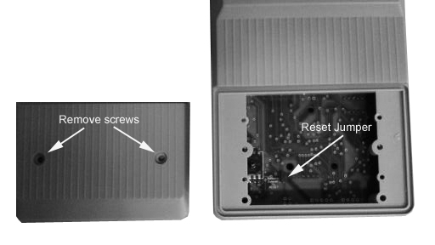
  - Remove unit from rubber boot.
  - Remove two screws that hold on bottom cover
  - Remove jumper to reset.
  - Wait one minute
  - Reinstall jumper
  - System should reboot
Unit will not loose data by reset/reboot. If unit does not function correctly after reset contact Tech Support.

ABBREVIATIONS
Temp | Temperature degrees Fahrenheit
Hum | Relative Humidity
Press | Barometric Pressure Inches of Mercury
DA | Density Altitude
OA | Oxygen Altitude
DP | Dew Point degrees Fahrenheit
VP | Vapor Pressure (inHG) inches of Mercury
GOW | Grains of Water grains per pound
ET | Elapsed Time
TS | Throttle Stop
SLET | Sea Level ET
ALT/ET | Ratio: change in ET for every 100’ change in Altitude
TSR | Throttle Stop Ratio
ADR | Air Density Ratio
CF | Horse Power Correction Factor
GUIDELINES FOR ACCURATE PREDICTIONS
For multiple run ET predicting it is recommended that 5 to 6 Good Runs be entered into a database and that there is a span of at least 1000’ feet in DA or OA between the runs.

Ex: Typical Data
Run #1 1223’ 10.20
Run #2 1301’ 10.204
Run #3 1956’ 10.236
Run #4 2000’ 10.237
Run #5 2245’ 10.249
Run #6 2269’ 10.25

For TS predicting it is also recommended that 5 to 6 runs be entered into a database and that there is a span of at least 1000’ feet in DA or OA between the runs. It is also recommended that there is some variance in the timer settings between the runs. In other words change the timer setting for at least 3 of the runs. The timer should be adjusted enough to cause up to a 0.30 second change in ET or generally a 2 second change.

Good Runs:
1. Altitude goes up, car loses performance/altitude goes down, car gains performance
2. 60’ times consistent, no tire slip
3. Wind effects minimal, 30 mph front or tail winds are not present
The more Good Runs and the more altitude span the more accurate your predictions will be.
******Important******
It often takes a number of trips to the track to acquire the above-recommended data in order to produce accurate results. Because of this, we suggest using the following method until enough data has been acquired or use the One Run Method.

Gasoline burning engines:
A 200’ rise in DA typically yields a 0.01sec slow down in ET and vice-versa for a drop in DA.

Alcohol burning engines:
A 400’ rise in DA typically yields a 0.01sec slow down in ET and vice-versa for a drop in DA.

For TS racers:
Typically the TS ratio is 3:1. This means is takes 0.03sec in the timer to move the car 0.01sec. Use this information with the above DA change to set up your timer.

APPENDIX

MAIN MENU
- SAMPLE AIR- View current weather conditions
- SETUP
- Select Weather
    - Grains
    - Dew Point
- Select Data Base
- Clear runs
- Change Name
- Select ET , TS, JET, PLATE mode
- Enter Index for TS mode
- Select DA or OA (optional)
- Select Multiple or One Run Predictions
- Select Wind Correction
- RUN ENTRY- Enter/View/Delete runs in database
- View Delete
- Add Runs
- CURRENT
- HELD
- MANUAL
- Altitude
- Temp,Pres,Hum
- PREDICT- Enter prediction mode
- CURRENT
- HELD
- MANUAL
a. Altitude
b. Temp,Pres,Hum
- DOWNLOAD- Download data base into PC
- SET CLOCK- Set Date and Time
- SHOW BAD RUNS – Displays runs that do not fit
- AUTO POWER OFF – Enable/Disable
- SAMPLE METHOD – sets SAMPLE AIR
  - Auto Stable
a. Set Stabilizing
  - Cont Sample
10 BATTERY CHECK

