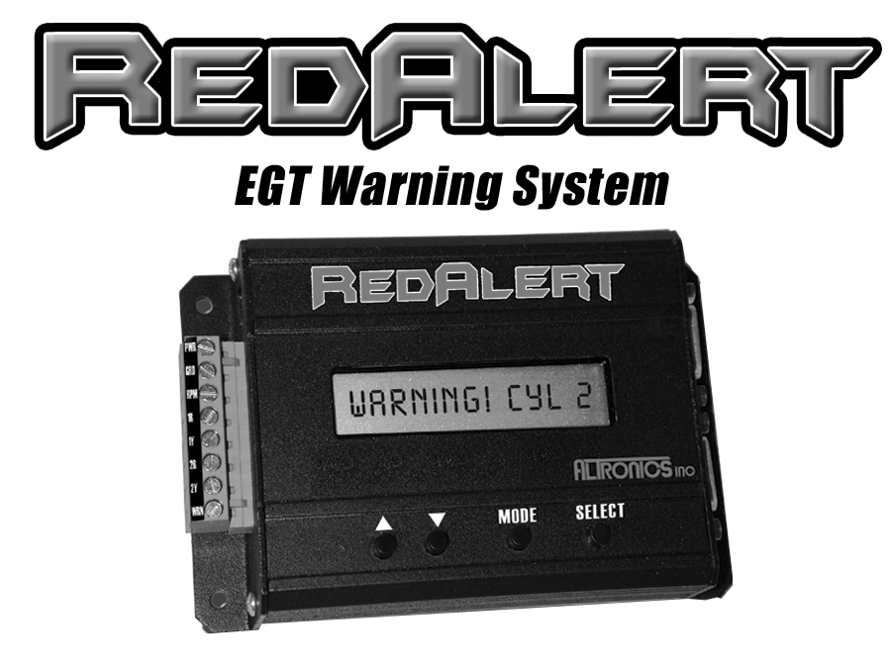

Invented and Manufactured

By
High Performance Electronic Components
1411 S. Roselle Rd, Schaumburg, IL 60193
Phone 847-923-0002 Fax 847-923-0004
www.AltronicsInc.com

Table of Contents
FEATURES 2
INSTALLING THE SYSTEM ____ 3
SYSTEM SETUP 8
OPERATING THE SYSTEM 9
RECORDING_____________________________ 9
PLAYBACK______________________________ 10
DOWNLOAD_____________________________ 10
INSTALLING THE RedAlert SOFTWARE___ 11 OPERATING SOFTWARE 12
WARRANTY 14
TECHNICAL SUPPORT 14
APPENDIX 15

REDALERT FEATURES

- Records Up to 8 EGT
- Records Engine RPM
- Warning Output with Settable Temperature
- On screen Readout.
- PC Not Needed
- Adjustable Sample Rate
- Download and Data Analysis Software
- Starts on RPM

INSTALLING SYSTEM
Mount REDALERT Unit in an easily accessible area on vehicle.

To avoid interference and damage to system do NOT use Solid Wire Core spark plug wires.
Connections to green terminal strip: (use #18 gauge wire)

PWR – POWER +12 or +16 volt DC source (vehicle battery). Fuse at 2 amps. Do Not hook to ignition power, power must stay on to save recording if you kill ignition power at end of run.
GND – Ground - chassis ground.
RPM – Engine RPM – connect to rpm output from ignition (DIGITAL Tach Signal Only. Do NOT connect to coil)
1R – EGT 1 red side
1Y – EGT 1 yellow side
2R - EGT 2 red side
2Y – EGT 2 yellow side
WRN – Warning Output – Normally Open contact, switched to Power (vehicle battery) upon warning activation. Connect to device you want to control when warning is activated. (Warning Light, NOS disable, Retard timing, shut off ignition). Output can only supply up to 2 amps, so if more power is needed connect warning output to a higher power control relay.

Note 1R, 1Y, 2R, 2Y are not used in systems with more then 2 EGT’s and should be left open.

Use following drawings to install EGT

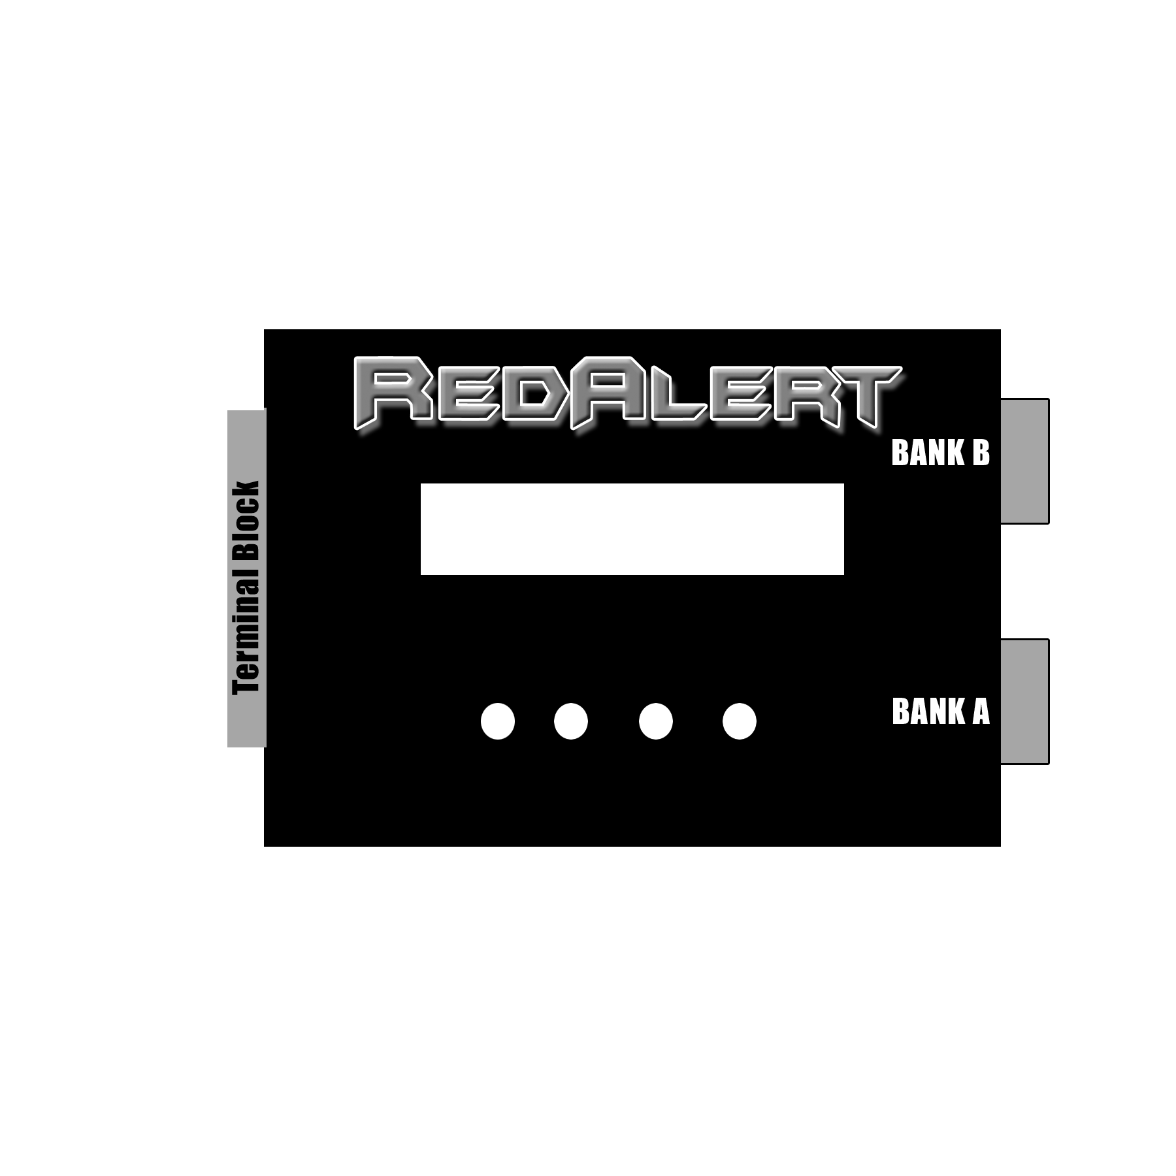
USB Port

*Attaching interface cables to junction box: It may be easier to remove PC Board screws and lift PC Board out of junction box to access terminal blocks. Strip back 1 inch of insulation on wire and wrap over end of wire then insert and tighten terminal block screw*
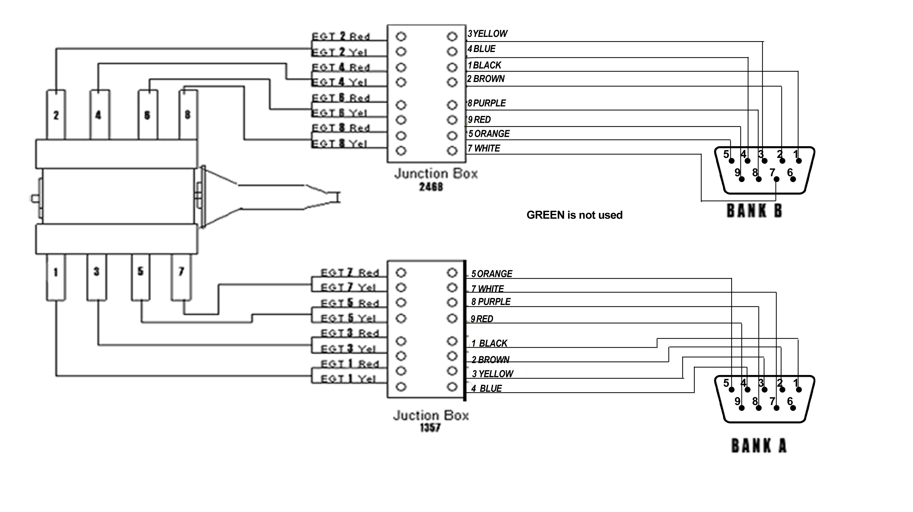

EGT (Thermocouple) WELDMENT INSTALLATION

1) Weldments should be placed equal distant to headers flanges. Up to 4” away is acceptable. Weldments should be placed the same distance away from the flange on each header, this is very important. Weld in small increments around the weldment as to not get the weldment excessively hot, which will cause it to warp. Verify orientation before welding, coupling can only be screwed in from one side!

- After weldment is welded in place, screw on the lower section of compression fitting.

- Using the hole in the lower part of compression fitting as a guide, drill an 3/16” hole through the header tube.

- Place ferrule and nut on fitting and then slide probe in fitting. Center the tip of the probe in the center of the header tube and tighten compression fitting.

- To shorten EGT wire at connection end: Cut clean through stainless braid at desired length. Slice 2” long piece of shrink tube over braid. Push back braid about 4” to expose Red and Yellow Wires. Now pull back braid leaving 2” of the Red and Yellow Wire exposed. Slide shrink tube leaving 1” of Red and Yellow wire exposed so shrink tube is till covering 1” of braid. Heat shrink tube.
EGT (Thermocouple) BAYONET INSTALLATION

- BAYONET should be placed the same distance away from the flange on each v header, this is very important. Up to 4” away is acceptable. They should also be in the same position in each header.
- Drill a 1/4” hole through the header tube. Tighten clamp onto header at desired location.

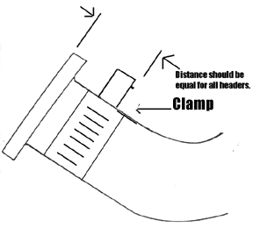
SET UP
To enter SETUP you must press and release the MODE key when “Redalert” appears on the LCD Display immediately after powering up the system.

After SETUP is entered the screen will prompt you to set the number of engine cylinders:

NUM OF CYL->_

Use the UP/DOWN buttons to set the appropriate number of cylinders. Then press SELECT.

Next select the Cylinder Order:

CYL ORDER->1234 or 1357

Using the UP/DOWN buttons your can change the cylinder order for each EGT BANK. If you set BANK A 1234 or 1357 then BANK B will be 5678 or 2468 respectively. If you are only running one or two EGT’s off of the green terminal block then use CYL ORDER ->1234.
Then press SELECT.

Next select the Start on RPM:

START ON RPM->Y or N

Using the UP/DOWN buttons your can set to start recording off of an engine RPM or Manual.
Then press SELECT.

If you select Y (Yes) you will be prompted to set the start RPM:

RPM->(value)

Using the UP/DOWN buttons your can set the RPM to start Recording.
Then press SELECT.

Next select the Arm on Power Up:

ARM ON PU->Y or N

START ON RPM must be enabled before this option will be activated.

Selecting Yes allows unit to arm itself when power is applied to unit. At this point it is waiting for RPM level to be reached and then will start recording. This feature allows there to be no user interaction to make a recording. Remember that after a run if power is cycled and start RPM level is reached unit will record again. Selecting No disables this feature and requires user to select RECORD from the main menu before unit will arm.

Next set Stop RPM.
STOP RPM-> XXX ( Typically 500 or less RPM)
Using the UP/DOWN buttons your can set the RPM to STOP Recording. (If unit sees RPM below set value it automatically stops recording.)
Then press SELECT.

Next set the Warning Temperature:

WARN TEMP->(value)

Using the UP/DOWN buttons your can set the temperature that will activate the Warning Output.
Then press SELECT.

Next set the Sample Rate:

SAMPLE RATE->1, 10, 100
Using the UP/DOWN buttons your can set the Sample Rate to 1, 10 or 100 samples per second. The slower the rate the longer the units will record and vice-versa. 1-200 minutes, 10-20 minutes, 100-2 minutes.
Then press SELECT.

OPERATING THE SYSTEM
After applying power to the system a greeting will be displayed as follows:
REDALERT
By Altronics

VERSION 1.0

Then will show:
RECORD

By using the UP/DOWN Buttons you can select one of the operating modes RECORD or PLAYBACK. You can enter into any of these modes by then pressing the SELECT button.

RECORD
It is recommended that you go through SETUP before RECORDING data.

Depending on how the system was configured in SETUP the display will read either Recording! or Armed!. If Start On RPM was enabled then the display will read Armed! until the preset RPM has been reached. Once the RPM has been reached the display will change to say Recording!. If Start On RPM was disabled the system will say Recording! immediately upon selecting the RECORD mode.

When you are in the RECORDING mode, the Red Alert will display “RECORDING 1” to indicate that it is recording to the first recording location, and “RECORDING 2” to indicate that it is recording to the second recording location.

The recording location will automatically alternate between the two possibilities. If you make a recording to recording location 1, the next recording will be placed in recording position 2.

The unit will record until one of the following conditions has been met.
- Max recording time has been reached.
- The MODE key is pressed
- The RPM dropped below Stop RPM.

If WARNING is activated during recording the a WARNING! Message will be display alternating with the Recording! message
After recording is has stopped the display will read Complete!
If a WARNING was activated during recording it will show the Cylinder number that tripped the warning after recording is complete.

PLAYBACK
After entering the PLAYBACK mode you can choose which Recording to Playback and which channel you want to view by using the UP/DOWN buttons. Once the channel you want is displayed press the SELECT button.

Now you can choose between 4 Playback modes. MIN/MAX, STEP, REALTIME, or LAUNCH. Press the SELECT button after using the UP/DOWN buttons to enter the playback mode desired.

MIN/MAX: Shows the Minimum and Maximum value of channel and time during recording that value occurred

STEP: Show the value of channel and time at each time interval during recording. Use the UP/DOWN buttons to scroll through the time of recording.

REALTIME: Shows the real time value of channel. Warning will activate during real time operation if warning temperature is met.

LAUNCH: Shows the channel value at beginning of recording.

Press MODE button to jump back to and select another channel to

DOWNLOAD
Downloading is controlled by the RedAlert Software Program on the PC.

To download plug in USB cable from RedAlert unit to PC. Follow instructions in Software.

INSTALLING SOFTWARE

To Install: Place RedAlert CD in computer and install should run automatically. If it does not, browse the CD and Run the “Setup.exe” file.
OPERATING SOFTWARE

The Redalert should be connected to the computer with the USB cable provided.

To run the Redalert software simply select Redalert from the Programs directory in the Start menu, or by clicking on the RedAlert icon from your desktop, as you would for any other program installed for Windows.

Download:
To download a run to the PC, select Download from the main menu screen, select the name of the file to save the download to, and finally you will be prompted to choose Recording 1 or Recording 2.

When Download is selected a File Select pop up menu will appear. You should enter the name of a file to keep the data you are going to download.
Ex: Indy_run_1.dat
All files should be kept in the C:\Redalert\Runs directory

After entering a file name and selecting OK another pop up panel will appear with directions for downloading
You will see the word Downloading appear on the Redalert display and also see “Downloading in Progress” appear on your computers monitor.

Wait unit it reaches 100%. When downloading is complete the Run Information box will appear and you can enter any parameters you may want for that run. Then press Save Run Info.

Redalert will return to its main menu and you can select to review the run. The Data Analysis interface will now appear on your monitor.

You can now click on the enabled channels and then hit GRAPH to plot them out.

Note: The small color boxes next to the enabled channel can be selected, which will then bring up a color chart, so you can select a different color to plot out the channel.

CURSOR: You can use your mouse to click on any point on the graph and a cursor will automatically be set showing the time and data value of that point. You can now use the arrow keys to move back and forth along the graph.

SMOOTHING: This feature allows you to set the amount of filtering for the graph. If there is noise in the plot of a channel to can use you mouse and click on the Smoothing slider to increase the amount of filtering. Click on GRAPH again to see a smother plot.
SET START OF RUN: You can set time = 0 at any point on the graph by left mouse clicking on at desired place on graph, then hit SET START OF RUN Button and then hit GRAPH button.

ZOOM: Hold CTRL key and Left mouse click on graph to ZOOM

PAN: Hold CTRL and SHIFT key and Left mouse click and drag on graph to PAN.

Review:
When Review is selected a File Select pop up menu will appear. You should select one of your previously downloaded runs for reviewing from the C:\Program Files\Redalert\Runs directory.

After selecting your run the Data Analysis interface will appear on your monitor

Review Multiple Run:
When Review Multiple Runs is selected two File Select pop up menus will appear to select base run and then to select Compare run.
After selecting your runs the Data Analysis interface will appear on your monitor

Real Time:
Allows for viewing real time data of all enabled channels in RedAlert on PC. You will be prompted to select Recording 1 or 2, it doesn’t matter which one you selected when in REALTIME!

WARRANTY

The REDALERT by is warranted for 1 Year (control box) against any defect in materials and workmanship from date of purchase. EGT probes are warranted for 30 days. ALL WARRANTIES AND GUARANTEES ARE VOID if the REDALERT enclosure is opened.

shall not be liable for injury, consequential, or other types of damages resulting from the use or misuse of the REDALERT

TECHNICAL SUPPORT
Email: tech@altronicsinc.com

When sending a unit in for repair or update: Fill out a “Service Form” which is available from the Technical Support Section of our website-> www.altronicsinc.com

APPENDIX

MAIN MENU
- SETUP
- NUMBER OF CYLINDERS
- CYLINDER ORDER
- START ON RPM
- RPM VALUE
- WARNING TEMPERATURE
- SAMPLE RATE

- RECORD
- PLAYBACK
- CHANNEL SELECT
- MIN/MAX
- STEP
- REALTIME
- LAUNCH

